D. A. V. PUBLIC SCHOOL, AUNDH, PUNE

INFORMATICS PRACTICES PROJECT FILE

TOPIC: LIBRARY MANAGEMENT SYSTEM

NAME: MANAS TRIVEDI

CLASS: XII – B

BOARD ROLL NUMBER: 4660439

Index

|  |  |  |
| --- | --- | --- |
| Sr. no. | Title | Pg. no. |
| 1. | Certificate | 1 |
| 2. | Acknowledgement | 2 |
| 3. | Introduction | 3 |
| 4. | User Interface Design | 5 |
| 5. | Import Statements and Declaration of Global Variables | 6 |
| 6. | Main Menu Frame | 7 |
| 7. | Code for components of Main Menu Frame | 8 |
| 8. | Book Details Frame | 9 |
| 9. | Code for components of Book Details frame | 10 |
| 10. | Member Details Frame | 15 |
| 11. | Code for components of Member Details Frame | 16 |
| 12. | Issue Book Frame | 20 |
| 13. | Code for components of Issue Book Frame | 21 |
| 14. | Return Book Frame | 25 |
| 15. | Code for components of Return Book Frame | 26 |
| 16. | History Frame | 30 |
| 17. | Code for components of History Frame | 31 |
| 18. | Code for Creation of MySQL Tables | 34 |
| 19. | MySQL Table Structures | 35 |
| 20. | Bibliography | 36 |

Acknowledgement

The completion of this project would not have been possible without the assistance of so many people, whose names may not have been enumerated. Their contributions are sincerely appreciated and gratefully acknowledged. However, I would like to express my gratitude and indebtedness particularly to the following:

Our Informatics Practices teacher, Ms. Gitanjali, and the Principal of our school, Mrs. C.V. Madhavi for their endless support and guidance.

To my parents, relatives, friends and others who in one way or the other shared their support, either morally, financially or physically.

Above all, to the Great Almighty for His countless blessings and love.

Introduction

A library management system, also known as an automated library system, is a software which can handle basic housekeeping functions of a library.

The system used in the project is to be operated by the librarian of a school library for a paperless, well-organized, faster and more efficient functioning of the library.

NetBeans IDE 6.5.1 has been used to develop the user interface of the application, while MySQL has been used as Database Management System for the data tables used in the application.

The operations that can be carried out by the system are listed below:

1. Adding a book/member to the library.

2. Updating the details of a book/member by using BookID/ MemberID.

3. Deleting a book/member from the library by using BookID/ MemberID.

4. Enquiring (viewing) the details of a book/member by using BookID/ MemberID.

5. Issuing a book to a member by using BookID and MemberID.

6. Withdrawing (returning) a book from a member by using BookID and MemberID.

7. Viewing the transaction (issue/return) history of the books and members.

* BookID uniquely identifies each book of the library.
* MemberID uniquely identifies each member of the library.

The librarian can carry out these tasks through six frames:

1. Main Menu Frame, which has buttons to navigate to the other frames, and to exit the application.

2. Book Details frame, where adding/updating/deleting of books is done.

3. Member Details frame, where adding/updating/deleting of members is done.

4. Issue Book frame, where books are issued to members.

5. Return Book frame, where books are withdrawn from members.

6. History frame, where transaction history of books/members can be viewed.

Information of books, members and book transactions (issue/return) is stored in three data tables: ‘Books’, ‘Members’ and ‘BookTRN’ respectively:

1. The Books table stores the BookID, title, name of the author, name of the publisher, ISBN number, price, and purchase date of the books.

2. The Members table stores the MemberID, name, class and section of the members.

3. The BookTRN table stores the BookID, title, MemberID, name, date of issue and date of return for each book issued or returned by the members.

User Interface Design

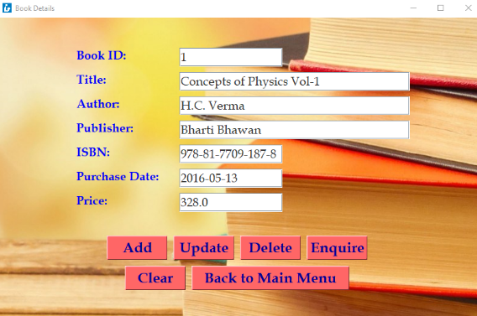 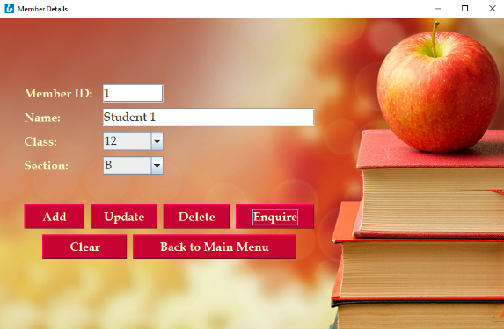



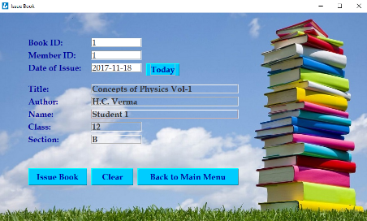 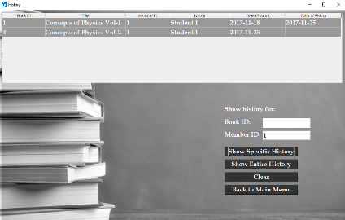 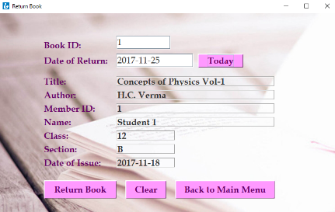

Import Statements and Declaration of Global Variables

import javax.swing.ImageIcon;

import java.sql.*;

import javax.swing.JOptionPane;

import javax.swing.table.DefaultTableModel;

public class LibraryManagementSystem extends javax.swing.JFrame {

Connection con=null;

Statement stmt=null;

ResultSet rs=null;

DefaultTableModel tm=null;

Main Menu Frame

bookDetailsButton issueBookButton memberDetailsButton



historyButton returnBookButton exitButton

Code for components of Main Menu Frame

private void **bookDetailsButtonActionPerformed**(java.awt.event.ActionEvent evt) {

this.dispose();

bookDetailsFrame.setVisible(true);

}

private void **memberDetailsButtonActionPerformed**(java.awt.event.ActionEvent evt) {

this.dispose();

memberDetailsFrame.setVisible(true);

}

private void **issueBookButtonActionPerformed**(java.awt.event.ActionEvent evt) {

this.dispose();

issueBookFrame.setVisible(true);

}

private void **returnBookButtonActionPerformed**(java.awt.event.ActionEvent evt) {

this.dispose();

returnBookFrame.setVisible(true);

}

private void **historyButtonActionPerformed**(java.awt.event.ActionEvent evt) {

this.dispose();

historyFrame.setVisible(true);

}

private void **exitButtonActionPerformed**(java.awt.event.ActionEvent evt) {

System.exit(0);

}

Book Details Frame

ISBN1TextField bookID1TextField publisher1TextField

price1TextField author1TextField title1TextField purchaseDate1TextField

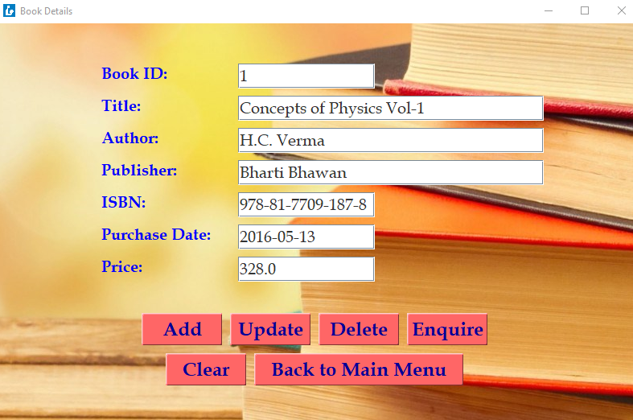

add1Button update1Button delete1Button enquire1Button

clear1Button return1Button

Code for components of Book Details Frame

private void **bookID1TextFieldActionPerformed**(java.awt.event.ActionEvent evt) {

title1TextField.requestFocus();

}

private void **title1TextFieldActionPerformed**(java.awt.event.ActionEvent evt) {

author1TextField.requestFocus();

}

private void **author1TextFieldActionPerformed**(java.awt.event.ActionEvent evt) {

publisher1TextField.requestFocus();

}

private void **publisher1TextFieldActionPerformed**(java.awt.event.ActionEvent evt) {

ISBN1TextField.requestFocus();

}

private void **ISBN1TextFieldActionPerformed**(java.awt.event.ActionEvent evt) {

purchaseDate1TextField.requestFocus();

}

private void **purchaseDate1TextFieldActionPerformed**(java.awt.event.ActionEvent evt) {

price1TextField.requestFocus();

}

private void **add1ButtonActionPerformed**(java.awt.event.ActionEvent evt) {

try{

con=DriverManager.getConnection("jdbc:mysql://localhost/Project", "root", "");

stmt=con.createStatement();

int bookid=Integer.parseInt(bookID1TextField.getText());

String title=title1TextField.getText();

String author=author1TextField.getText();

String publisher=publisher1TextField.getText();

String isbn=ISBN1TextField.getText();

Double price=Double.parseDouble(price1TextField.getText());

String purchasedate=purchaseDate1TextField.getText();

String sql="insert into books values("+bookid+", '"+title+"', '"+author+"', '"+publisher+"', '"+isbn+"', "+price+", '"+purchasedate+"');";

System.out.println(sql);

stmt.executeUpdate(sql);

bookID1TextField.setText("");

title1TextField.setText("");

author1TextField.setText("");

publisher1TextField.setText("");

ISBN1TextField.setText("");

price1TextField.setText("");

purchaseDate1TextField.setText("");

JOptionPane.showMessageDialog(null, "Data entered.");

bookID1TextField.requestFocus();

}

catch(Exception e){

JOptionPane.showMessageDialog(null, e.getMessage());

}

}

private void **update1ButtonActionPerformed**(java.awt.event.ActionEvent evt) {

try{

con=DriverManager.getConnection("jdbc:mysql://localhost/Project", "root", "");

stmt=con.createStatement();

int bookid=Integer.parseInt(bookID1TextField.getText());

String title=title1TextField.getText();

String author=author1TextField.getText();

String publisher=publisher1TextField.getText();

String isbn=ISBN1TextField.getText();

Double price=Double.parseDouble(price1TextField.getText());

String purchasedate=purchaseDate1TextField.getText();

String sql="update books set title='"+title+"', author='"+author+"', publisher='"+publisher+"', isbn='"+isbn+"', price="+price+", purchasedate='"+purchasedate+"' where bookid="+bookid+";";

System.out.println(sql);

stmt.executeUpdate(sql);

bookID1TextField.setText("");

title1TextField.setText("");

author1TextField.setText("");

publisher1TextField.setText("");

ISBN1TextField.setText("");

price1TextField.setText("");

purchaseDate1TextField.setText("");

JOptionPane.showMessageDialog(null, "Data updated.");

bookID1TextField.requestFocus();

}

catch(Exception e){

JOptionPane.showMessageDialog(null, e.getMessage());

}

}

private void **delete1ButtonActionPerformed**(java.awt.event.ActionEvent evt) {

try{

con=DriverManager.getConnection("jdbc:mysql://localhost/Project", "root", "");

stmt=con.createStatement();

int bookid=Integer.parseInt(bookID1TextField.getText());

String sql="delete from books where bookid="+bookid+";";

System.out.println(sql);

stmt.executeUpdate(sql);

bookID1TextField.setText("");

title1TextField.setText("");

author1TextField.setText("");

publisher1TextField.setText("");

ISBN1TextField.setText("");

price1TextField.setText("");

purchaseDate1TextField.setText("");

JOptionPane.showMessageDialog(null, "Data deleted.");

bookID1TextField.requestFocus();

}

catch(Exception e){

JOptionPane.showMessageDialog(null, e.getMessage());

}

}

private void **enquire1ButtonActionPerformed**(java.awt.event.ActionEvent evt) {

try{

con=DriverManager.getConnection("jdbc:mysql://localhost/Project", "root", "");

stmt=con.createStatement();

int bookid=Integer.parseInt(bookID1TextField.getText());

String sql="select * from books where bookid="+bookid+";";

System.out.println(sql);

rs=stmt.executeQuery(sql);

rs.first();

title1TextField.setText(rs.getString("Title"));

author1TextField.setText(rs.getString("Author"));

publisher1TextField.setText(rs.getString("Publisher"));

ISBN1TextField.setText(rs.getString("ISBN"));

price1TextField.setText(""+rs.getDouble("Price"));

purchaseDate1TextField.setText(""+rs.getDate("PurchaseDate"));

}

catch(Exception e){

JOptionPane.showMessageDialog(null, e.getMessage());

}

}

private void **clear1ButtonActionPerformed**(java.awt.event.ActionEvent evt) {

bookID1TextField.setText("");

title1TextField.setText("");

author1TextField.setText("");

publisher1TextField.setText("");

ISBN1TextField.setText("");

price1TextField.setText("");

purchaseDate1TextField.setText("");

bookID1TextField.requestFocus();

}

private void **return1ButtonActionPerformed**(java.awt.event.ActionEvent evt) {

bookDetailsFrame.dispose();

bookID1TextField.setText("");

title1TextField.setText("");

author1TextField.setText("");

publisher1TextField.setText("");

ISBN1TextField.setText("");

price1TextField.setText("");

purchaseDate1TextField.setText("");

this.setVisible(true);

}

Member Details Frame

class2ComboBox memberID2TextField name2TextField section2ComboBox

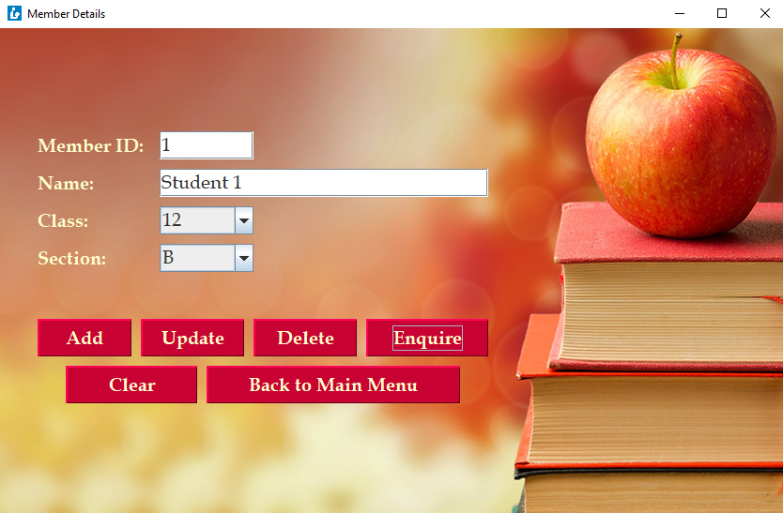

add2Button update2Button delete2Button enquire2Button

clear2Button return2Button

Code for components of Member Details Frame

private void **memberID2TextFieldActionPerformed**(java.awt.event.ActionEvent evt) {

name2TextField.requestFocus();

}

private void **add2ButtonActionPerformed**(java.awt.event.ActionEvent evt) {

try{

con=DriverManager.getConnection("jdbc:mysql://localhost/Project", "root", "");

stmt=con.createStatement();

int memberid=Integer.parseInt(memberID2TextField.getText());

String name=name2TextField.getText();

String c=(String)class2ComboBox.getSelectedItem();

String section=(String)section2ComboBox.getSelectedItem();

String sql="insert into members values("+memberid+", '"+name+"', "+c+", '"+section+"');";

System.out.println(sql);

stmt.executeUpdate(sql);

memberID2TextField.setText("");

name2TextField.setText("");

class2ComboBox.setSelectedIndex(0);

section2ComboBox.setSelectedIndex(0);

JOptionPane.showMessageDialog(null, "Data entered.");

memberID2TextField.requestFocus();

}

catch(Exception e){

JOptionPane.showMessageDialog(null, e.getMessage());

}

}

private void **update2ButtonActionPerformed**(java.awt.event.ActionEvent evt) {

try{

con=DriverManager.getConnection("jdbc:mysql://localhost/Project", "root", "");

stmt=con.createStatement();

int memberid=Integer.parseInt(memberID2TextField.getText());

String name=name2TextField.getText();

String c=(String)class2ComboBox.getSelectedItem();

String section=(String)section2ComboBox.getSelectedItem();

String sql="update members set name='"+name+"', class="+c+", section='"+section+"' where memberid="+memberid+";";

System.out.println(sql);

stmt.executeUpdate(sql);

memberID2TextField.setText("");

name2TextField.setText("");

class2ComboBox.setSelectedIndex(0);

section2ComboBox.setSelectedIndex(0);

JOptionPane.showMessageDialog(null, "Data updated.");

memberID2TextField.requestFocus();

}

catch(Exception e){

JOptionPane.showMessageDialog(null, e.getMessage());

}

}

private void **delete2ButtonActionPerformed**(java.awt.event.ActionEvent evt) {

try{

con=DriverManager.getConnection("jdbc:mysql://localhost/Project", "root", "");

stmt=con.createStatement();

int memberid=Integer.parseInt(memberID2TextField.getText());

String sql="delete from members where memberid="+memberid+";";

System.out.println(sql);

stmt.executeUpdate(sql);

memberID2TextField.setText("");

name2TextField.setText("");

class2ComboBox.setSelectedIndex(0);

section2ComboBox.setSelectedIndex(0);

JOptionPane.showMessageDialog(null, "Data deleted.");

memberID2TextField.requestFocus();

}

catch(Exception e){

JOptionPane.showMessageDialog(null, e.getMessage());

}

}

private void **enquire2ButtonActionPerformed**(java.awt.event.ActionEvent evt) {

try{

con=DriverManager.getConnection("jdbc:mysql://localhost/Project", "root", "");

stmt=con.createStatement();

int memberid=Integer.parseInt(memberID2TextField.getText());

String sql="select * from members where memberid="+memberid+";";

System.out.println(sql);

rs=stmt.executeQuery(sql);

rs.first();

name2TextField.setText(rs.getString("Name"));

class2ComboBox.setSelectedItem(rs.getString("Class"));

section2ComboBox.setSelectedItem(rs.getString("Section"));

}

catch(Exception e){

JOptionPane.showMessageDialog(null, e.getMessage());

}

}

private void **clear2ButtonActionPerformed**(java.awt.event.ActionEvent evt) {

memberID2TextField.setText("");

name2TextField.setText("");

class2ComboBox.setSelectedIndex(0);

section2ComboBox.setSelectedIndex(0);

memberID2TextField.requestFocus();

}

private void **return2ButtonActionPerformed**(java.awt.event.ActionEvent evt) {

memberDetailsFrame.dispose();

memberID2TextField.setText("");

name2TextField.setText("");

class2ComboBox.setSelectedIndex(0);

section2ComboBox.setSelectedIndex(0);

this.setVisible(true);

}

Issue Book Frame

memberID3TextField title3OutputLabel

dateOfIssue3TextField bookID3TextField today3Button author3OutputLabel

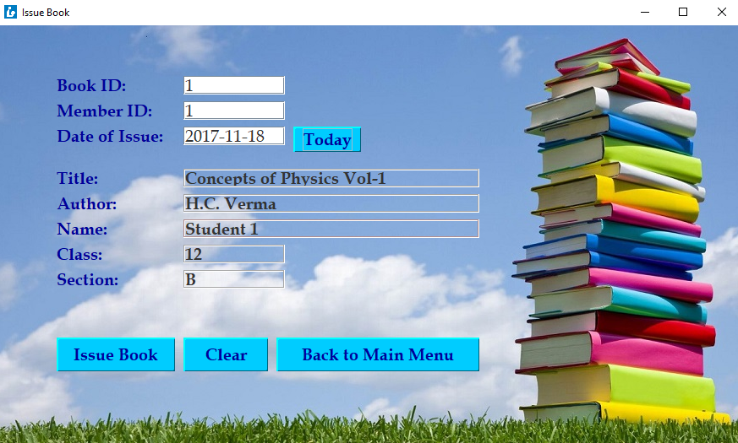

issueBook3Button clear3Button class3OutputLabel name3OutputLabel

section3OutputLabel return3Button

Code for components of Issue Book Frame

private void **bookID3TextFieldActionPerformed**(java.awt.event.ActionEvent evt) {

try{

con=DriverManager.getConnection("jdbc:mysql://localhost/Project", "root", "");

stmt=con.createStatement();

int bookid=Integer.parseInt(bookID3TextField.getText());

String sql="select * from books where bookid="+bookid+";";

System.out.println(sql);

rs=stmt.executeQuery(sql);

rs.first();

title3OutputLabel.setText(rs.getString("Title"));

author3OutputLabel.setText(rs.getString("Author"));

memberID3TextField.requestFocus();

}

catch(Exception e){

JOptionPane.showMessageDialog(null, e.getMessage());

}

}

private void **memberID3TextFieldActionPerformed**(java.awt.event.ActionEvent evt) {

try{

con=DriverManager.getConnection("jdbc:mysql://localhost/Project", "root", "");

stmt=con.createStatement();

int memberid=Integer.parseInt(memberID3TextField.getText());

String sql="select * from members where memberid="+memberid+";";

System.out.println(sql);

rs=stmt.executeQuery(sql);

rs.first();

name3OutputLabel.setText(rs.getString("Name"));

class3OutputLabel.setText(rs.getString("Class"));

section3OutputLabel.setText(rs.getString("Section"));

dateOfIssue3TextField.requestFocus();

}

catch(Exception e){

JOptionPane.showMessageDialog(null, e.getMessage());

}

}

private void **today3ButtonActionPerformed**(java.awt.event.ActionEvent evt) {

try{

con=DriverManager.getConnection("jdbc:mysql://localhost/Project", "root", "");

stmt=con.createStatement();

String sql="Select curdate();";

System.out.println(sql);

rs=stmt.executeQuery(sql);

rs.first();

dateOfIssue3TextField.setText(rs.getString(1));

}

catch(Exception e){

JOptionPane.showMessageDialog(null, e.getMessage());

}

}

private void **issueBook3ButtonActionPerformed**(java.awt.event.ActionEvent evt) {

try{

con=DriverManager.getConnection("jdbc:mysql://localhost/Project", "root", "");

stmt=con.createStatement();

int bookid=Integer.parseInt(bookID3TextField.getText());

rs=stmt.executeQuery("Select title from books where bookid="+bookid+";");

rs.first();

String title=rs.getString("Title");

int memberid=Integer.parseInt(memberID3TextField.getText());

rs=stmt.executeQuery("Select name from members where memberid="+memberid+";");

rs.first();

String name=rs.getString("Name");

String issuedate=dateOfIssue3TextField.getText();

String sql1="Select * from booktrn where bookid="+bookid+" and returndate is null;";

rs=stmt.executeQuery(sql1);

if(rs.next()){

JOptionPane.showMessageDialog(null, "This book has already been issued.");

}

else{

String sql="insert into BookTRN (bookid, title, memberid, name, issuedate) values("+bookid+", '"+title+"', "+memberid+", '"+name+"', '"+issuedate+"');";

System.out.println(sql);

stmt.executeUpdate(sql);

bookID3TextField.setText("");

memberID3TextField.setText("");

dateOfIssue3TextField.setText("");

title3OutputLabel.setText("");

author3OutputLabel.setText("");

name3OutputLabel.setText("");

class3OutputLabel.setText("");

section3OutputLabel.setText("");

JOptionPane.showMessageDialog(null, "Book issued.");

bookID3TextField.requestFocus();

}

}

catch(Exception e){

JOptionPane.showMessageDialog(null, e.getMessage());

}

}

private void **clear3ButtonActionPerformed**(java.awt.event.ActionEvent evt) {

bookID3TextField.setText("");

memberID3TextField.setText("");

dateOfIssue3TextField.setText("");

title3OutputLabel.setText("");

author3OutputLabel.setText("");

name3OutputLabel.setText("");

class3OutputLabel.setText("");

section3OutputLabel.setText("");

bookID3TextField.requestFocus();

}

private void **return3ButtonActionPerformed**(java.awt.event.ActionEvent evt) {

issueBookFrame.dispose();

bookID3TextField.setText("");

memberID3TextField.setText("");

dateOfIssue3TextField.setText("");

title3OutputLabel.setText("");

author3OutputLabel.setText("");

name3OutputLabel.setText("");

class3OutputLabel.setText("");

section3OutputLabel.setText("");

this.setVisible(true);

}

Return Book Frame

dateOfReturn4TextField author4OutputLabel

title4OutputLabel bookID4TextField today4Button memberID4OutputLabel

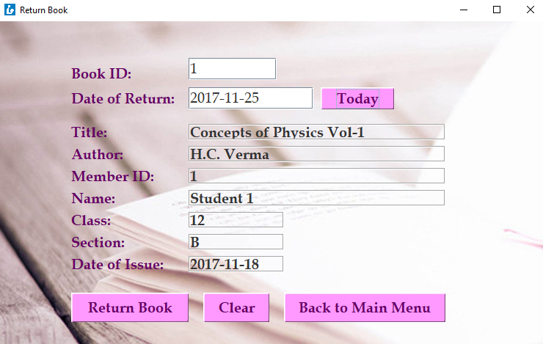

returnBook4Button clear4Button section4OutputLabel class4OutputLabel

dateOfIssue4OutputLabel return4Button

Code for components of Return Book Frame

private void **bookID4TextFieldActionPerformed**(java.awt.event.ActionEvent evt) {

try{

con=DriverManager.getConnection("jdbc:mysql://localhost/Project", "root", "");

stmt=con.createStatement();

int bookid=Integer.parseInt(bookID4TextField.getText());

String sql="Select booktrn.bookid, books.title, author, booktrn.memberid, members.name, class, section, issuedate from books, members, booktrn where books.bookid=booktrn.bookid and members.memberid=booktrn.memberid and booktrn.bookid="+bookid+";";

System.out.println(sql);

rs=stmt.executeQuery(sql);

rs.first();

title4OutputLabel.setText(rs.getString("Title"));

author4OutputLabel.setText(rs.getString("Author"));

memberID4OutputLabel.setText(rs.getString("MemberID"));

name4OutputLabel.setText(rs.getString("Name"));

class4OutputLabel.setText(rs.getString("Class"));

section4OutputLabel.setText(rs.getString("Section"));

dateOfIssue4OutputLabel.setText(rs.getString("IssueDate"));

dateOfReturn4TextField.requestFocus();

}

catch(Exception e){

JOptionPane.showMessageDialog(null, e.getMessage());

}

}

private void **today4ButtonActionPerformed**(java.awt.event.ActionEvent evt) {

try{

con=DriverManager.getConnection("jdbc:mysql://localhost/Project", "root", "");

stmt=con.createStatement();

String sql="select curdate();";

System.out.println(sql);

rs=stmt.executeQuery(sql);

rs.first();

dateOfReturn4TextField.setText(rs.getString(1));

}

catch(Exception e){

JOptionPane.showMessageDialog(null, e.getMessage());

}

}

private void **returnBook4ButtonActionPerformed**(java.awt.event.ActionEvent evt) {

try{

con=DriverManager.getConnection("jdbc:mysql://localhost/Project", "root", "");

stmt=con.createStatement();

int bookid=Integer.parseInt(bookID4TextField.getText());

String returndate=dateOfReturn4TextField.getText();

String sql1="Select * from booktrn where bookid="+bookid+" and returndate is null;";

rs=stmt.executeQuery(sql1);

if(rs.next()){

String sql="update BookTRN set returndate='"+returndate+"' where bookid="+bookid+" and returndate is null;";

System.out.println(sql);

stmt.executeUpdate(sql);

bookID4TextField.setText("");

dateOfReturn4TextField.setText("");

title4OutputLabel.setText("");

author4OutputLabel.setText("");

name4OutputLabel.setText("");

class4OutputLabel.setText("");

section4OutputLabel.setText("");

dateOfIssue4OutputLabel.setText("");

memberID4OutputLabel.setText("");

JOptionPane.showMessageDialog(null, "Book returned.");

bookID4TextField.requestFocus();

}

else{JOptionPane.showMessageDialog(null, "This book has already been returned, or has not been issued yet, or does not exist.");

}

}

catch(Exception e){

JOptionPane.showMessageDialog(null, e.getMessage());

}

}

private void **clear4ButtonActionPerformed**(java.awt.event.ActionEvent evt) {

bookID4TextField.setText("");

dateOfReturn4TextField.setText("");

title4OutputLabel.setText("");

author4OutputLabel.setText("");

name4OutputLabel.setText("");

class4OutputLabel.setText("");

section4OutputLabel.setText("");

dateOfIssue4OutputLabel.setText("");

memberID4OutputLabel.setText("");

bookID4TextField.requestFocus();

}

private void **return4ButtonActionPerformed**(java.awt.event.ActionEvent evt) {

returnBookFrame.dispose();

bookID4TextField.setText("");

dateOfReturn4TextField.setText("");

title4OutputLabel.setText("");

author4OutputLabel.setText("");

name4OutputLabel.setText("");

class4OutputLabel.setText("");

section4OutputLabel.setText("");

dateOfIssue4OutputLabel.setText("");

memberID4OutputLabel.setText("");

this.setVisible(true);

}

History Frame

history5Table bookID5TextField memberID5TextField

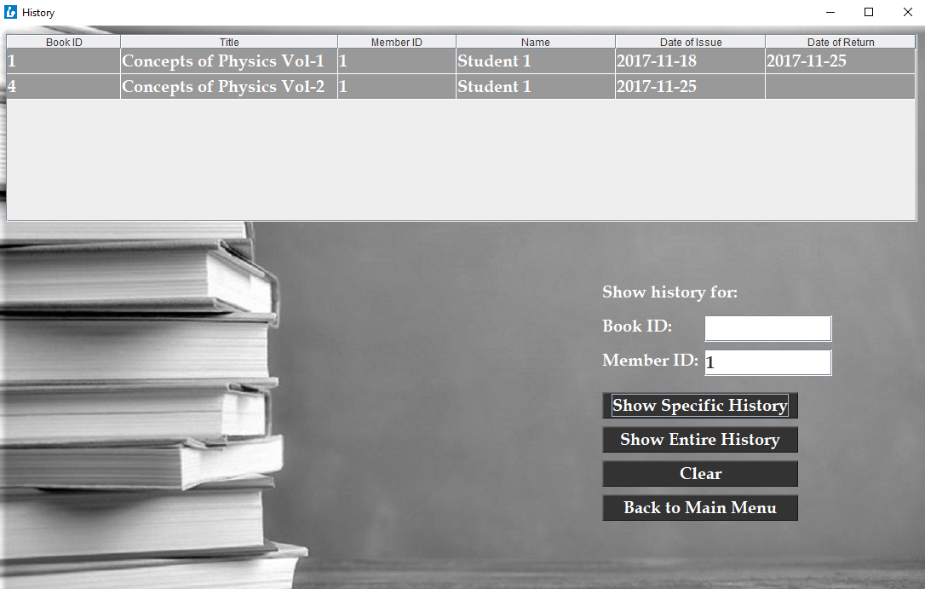

showSpecificHistory5Button showEntireHistory5Button clear5Button return5Button

Code for components of History Frame

private void **historyFrameWindowActivated**(java.awt.event.WindowEvent evt) {

tm=(DefaultTableModel)history5Table.getModel();

bookID5TextField.requestFocus();

}

private void **bookID5TextFieldActionPerformed**(java.awt.event.ActionEvent evt) {

memberID5TextField.requestFocus();

}

private void **showSpecificHistory5ButtonActionPerformed**(java.awt.event.ActionEvent evt) {

try{

tm.setRowCount(0);

con=DriverManager.getConnection("jdbc:mysql://localhost/Project", "root", "");

stmt=con.createStatement();

String b=bookID5TextField.getText();

String m=memberID5TextField.getText();

String sql="";

if(b.equals("")&&m.equals("")){

JOptionPane.showMessageDialog(null, "Please enter Book ID and/or Member ID to view specific history.");

bookID5TextField.requestFocus();

}

else{

if(b.equals("")){

int memberid=Integer.parseInt(m);

sql="Select * from BookTRN where memberid="+memberid+";";

}

else if(m.equals("")){

int bookid=Integer.parseInt(b);

sql="Select * from BookTRN where bookid="+bookid+";";

}

else{

int bookid=Integer.parseInt(b);

int memberid=Integer.parseInt(m);

sql="Select * from BookTRN where bookid="+bookid+" and memberid="+memberid+";";

}

rs=stmt.executeQuery(sql);

while(rs.next()){

tm.addRow(new Object [] {rs.getInt("BookID"), rs.getString("Title"), rs.getInt("MemberID"), rs.getString("Name"), rs.getString("IssueDate"), rs.getString("ReturnDate")});

}

bookID5TextField.requestFocus();

}

}

catch(Exception e){

JOptionPane.showMessageDialog(null, e.getMessage());

}

}

private void **showEntireHistory5ButtonActionPerformed**(java.awt.event.ActionEvent evt) {

bookID5TextField.setText("");

memberID5TextField.setText("");

try{

tm.setRowCount(0);

con=DriverManager.getConnection("jdbc:mysql://localhost/Project", "root", "");

stmt=con.createStatement();

String sql="Select * from BookTRN";

rs=stmt.executeQuery(sql);

while(rs.next()){

tm.addRow(new Object [] {rs.getInt("BookID"), rs.getString("Title"), rs.getInt("MemberID"), rs.getString("Name"), rs.getString("IssueDate"), rs.getString("ReturnDate")});

}

bookID5TextField.requestFocus();

}

catch(Exception e){

JOptionPane.showMessageDialog(null, e.getMessage());

}

}

private void **clear5ButtonActionPerformed**(java.awt.event.ActionEvent evt) {

bookID5TextField.setText("");

memberID5TextField.setText("");

tm.setRowCount(0);

bookID5TextField.requestFocus();

}

private void **backToMainMenu5ButtonActionPerformed**(java.awt.event.ActionEvent evt) {

historyFrame.dispose();

bookID5TextField.setText("");

memberID5TextField.setText("");

tm.setRowCount(0);

this.setVisible(true);

}

Code for creation of MySQL Tables

create database project;

use project;

create table books

(BookID int Primary Key,

Title varchar(40),

Author varchar(40),

Publisher varchar(40),

ISBN varchar(40),

Price decimal(7,2),

PurchaseDate date);

create table members

(MemberID int Primary Key,

Name varchar(40),

Class int,

Section char(1));

create table booktrn

(BookID int,

Title varchar(40),

MemberID int,

Name varchar(40),

IssueDate date,

ReturnDate date,

Foreign Key(BookID) references books(BookID) on update cascade on delete cascade,

Foreign Key(MemberID) references members(MemberID) on update cascade on delete cascade);

MySQL Table Structures

1. Books

|  |  |  |
| --- | --- | --- |
| Field | Type | Key |
| BookID | int(11) | Primary Key |
| Title | varchar(40) |  |
| Author | varchar(40) |  |
| Publisher | varchar(40) |  |
| ISBN | varchar(20) |  |
| Price | decimal(7, 2) |  |
| PurchaseDate | date |  |

2. Members

|  |  |  |
| --- | --- | --- |
| Field | Type | Key |
| MemberID | int(11) | Primary Key |
| Name | varchar(40) |  |
| Class | int(11) |  |
| Section | char(1) |  |

3. BookTRN

|  |  |  |
| --- | --- | --- |
| Field | Type | Key |
| BookID | int(11) | Foreign Key references Books (BookID) |
| Title | varchar(40) |  |
| MemberID | int(11) | Foreign Key references Members (MemberID) |
| Name | varchar(40) |  |
| IssueDate | date |  |
| ReturnDate | date |  |

Bibliography

Sumita Arora (2002): Informatics Practices for Class XII (Dhanpat Rai & Co. (P) Ltd., Delhi)

<https://en.wikipedia.org/wiki/Library_computer_system>

<https://en.wikipedia.org/wiki/Integrated_library_system>